**Some more points on SEO (Brief points)**

**On Page SEO**

On Page SEO refers to settings you can apply on your website so that it is optimized for search engines. The most important On-Page SEO tips are:

* Having optimized titles and descriptions
* Proper URL Structures
* User friendly navigation (breadcrumbs, user sitemaps)
* [**Optimized internal links**](https://www.reliablesoft.net/internal-linking-best-practices-for-seo/)
* Text Formatting (use of h1,h2,bold etc)
* Image optimization (image size, proper image names, use of ALT tag)
* User friendly 404 pages
* Fast loading pages
* Mobile Friendly pages
* Top quality fresh content (This is always the most important SEO factor!)
* External links (no broken links or links to ‘bad’ sites)

**PAGE RANK**

One of the founders of google is larry page. And this page rank is the main feature based on which the entire search engine was created.

Now what is page rank? Page rank is an algorithem using which google ranks various sites in its search results.

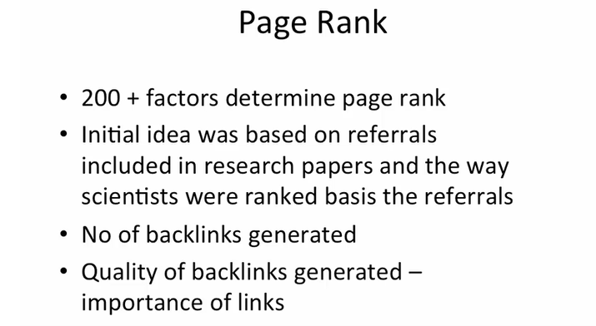

There are 200+ factors that are used to determine the page rank.The initial idea behind this was based on referrals included in research papers and the way scientists were ranked basis the referrals.What happens in that is lykk if you are a very popular scientist like for example we talk about Einstein or newton then if another scientist writing about something the topic relating to the field of popular scientist.Then they will surely quote you or give reference of the popular scientist.and jo scientist jitna zyada quote hogaa kisi bhi research paper mein..uski value utni hi zyadaa hogi.SO by this referring process list is made lykk which are the good scientist which are low and so on.

So based on this concept only ,larry page discovered the method of ranking the websites.

So if you own a website in which you are talking about how to design a website and you provide a quality info , and providing a good content to the users. Then you will automatically be quoted by many website owners in their website who are in the same field. Whenever you refer someone or someone is referring you in its site then in the form of referrals a link is shared basically.

That shared link is known as BACKLINK.

There are some methods by which people used to create backlinks.

Like There are many popular sites blogging sites specially like inc42.com.These sites allow people to create their account and they can publish their articles on that site. And while writing they can put link of their website.so indirectly if any user read that blog and finds it intresting then chances of visiting your website through the referring site increases. As Lots of traffic visit that popular website therefore it is quite useful to put oneself site link on that websites.

But this process will not work if one of your frnd who writes blogs are putting ur site link on his or her website. This is beneficial only if the link is shared with popular and highly rank sites. Suppose if your link appears on many such websites then google will consider that so many sites are referring this website. Therefore it must be ranked higher.

SO google gives the right weightage basis the formula that they use So the concept is if you are provided a backlink by a site like times of india then that is many tyms worth than the backlink provided by your frnd having a blog site.SO this is what we call quality of links.

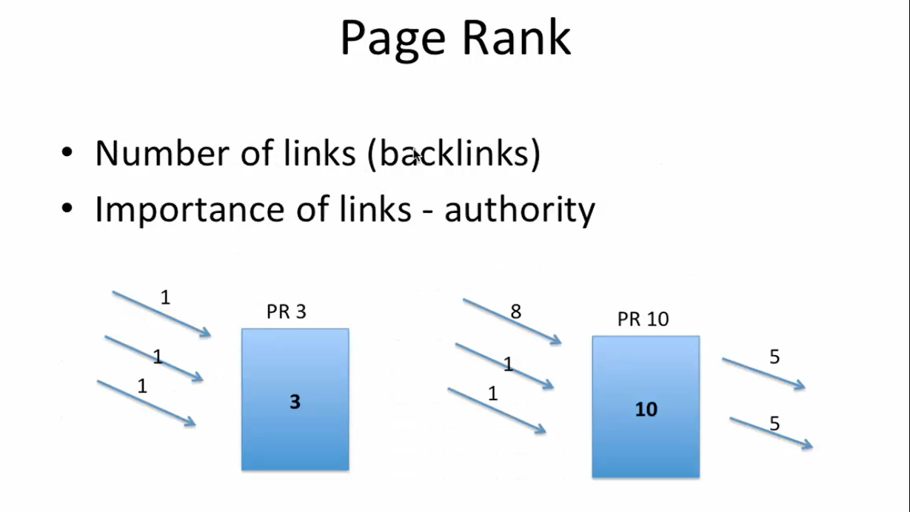

This image is showing how the quality of links is determined by google

Consider **box 3**(aese hi name diyaa hai suppose ok) is a website and total 3 links are provided by 3 different websites jinko google 1 point de rhaa hai. SO this website got 3 points by google.And this is how google is calculating the page rank of this website.

Page rank= number of links* their weightage

Now consider another website say PR 10 and 3 different links are provided by 3 different sites. But one link is provided by times of india which is very valuable and therefore google gives it 8 points and other 2 links are generated by simple websites. Therefore total points are 10 so the website rank is 10 .

Now lykk this website is now having 10 points so it can be further be distributed equally 5 5 poiints to two sites. If this site provides link to 10 websites then each link will carry 1 point each.If 100 links then each will have 0.1 point. Lykk time of india has a good weightage of links then if it is distributed to few websites them the link will be of high points.

One more thing google is cheez ko valuable nhi mantaa ki kitne backlinks hain..ye nhi honaa chahiye ki 100 backlinks hain ..infact log isko business bnaate hai..backlinks ke liye paise bhi dete or lete hain.but google ko ye baat smjh me aati hai isliye…kamm hon links bt valuable quality vale hon…sirf vhi site high rank kregi..

If you r providing linsk to random sites..toh it is useless.. hmeshaa sites ko check krke hi link provide krnaa chahiye.

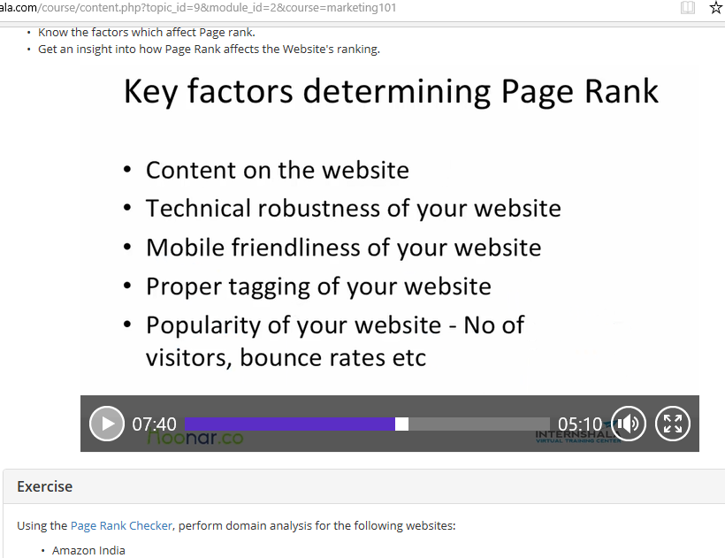

Other factors are mentioned above

Technical robustness of your website is – Loading of your website means how fast your website loads, broken pages kitne hai website me. Broken pages means links valid hon…ye naa ho ki link pe click krne pe link khule naa..

Proper tagging means providing right headline, right metatag, right description honi chahiye.

Then is popularity of your website , bounce rate is ki aapki site ko koi kholtaa hai to kitni der khole rkhtaa hai..ye nhi ki kholkr ek dum bnd krde..agr aesaa hotaa hai toh bounce rate high hojataa hai.

One can check their sites page rank by page rank checker sites

<https://www.checkpagerank.net/>

<https://www.pagerank.net/pagerank-checker/>

<https://www.prchecker.info/check_page_rank.php>

Off page SEO

It is basically Link building

**Off Page Optimization**

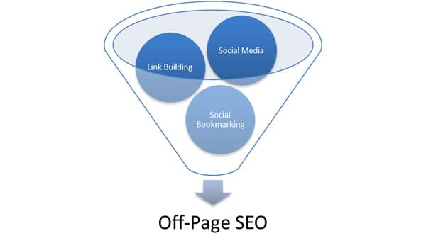

Off page optimization is the factors and elements that have a huge effect on your website for the organic and natural search engine results. These factors are off-site qw they are not controlled by you or the coding of your page. It is based on the popularity of website. Off Page optimization refers to techniques and search engine ranking but are not on the web page. This includes competitive link research, planning and design and link building campaigns.

Unlike On- page SEO, Off-page SEO refers to activities you can perform outside the boundaries of your website. The most important are:

* [**Link Building**](https://www.reliablesoft.net/link-building-techniques/)
* Social Media Marketing
* Social bookmarking

### Why is Off-Page SEO important?

Search engines have been trying for decades to find a way to return the best results to the searcher.

Off page SEO gives them a very good indication on how the World (other websites and users) perceive the particular website. A web site that is high quality and useful is more likely to have references (links) from other websites; it is more likely to have mentions on social media (Facebook likes, tweets, Pins, +1’s etc.) and it is more likely to be bookmarked and shared among same type websites.

### What are the benefits of ‘off-site SEO’ to website owners?

A successful off-site SEO strategy will generate the following benefits to website owners:

**Increase in rankings** – The website will rank higher in the SERPs and this also means more traffic.

**Increase in PageRank** – Page rank is a number between 0 and 10 which indicates the importance of a website in the eyes of Google. It is the system invented by Larry Page and Sergey Brin (Google founders) and one of the reasons that Google was so successful in showing the most relevant results to the searcher.  Page rank today is only one out of the 250 factors that Google is using to rank websites.

**More exposure** – Higher rankings also means greater exposure because when a website ranks in the top positions: it gets more links, more visits and more social media mentions. It’s like a never ending sequence of events where one thing leads to another and then to another etc.

## Link Building

Link building is the most popular and [**effective**](https://www.reliablesoft.net/how-to-drive-traffic-to-your-blog/) off-Page SEO method.  Basically by building external links to your website, you are trying to gather as many ‘votes’ as you can, so that you can bypass your competitors and rank higher.

For example, if someone likes this article and references it from his/her website or blog, then this is like telling search engines that this page has good information.

Over the years webmasters have been trying to build links to their websites to get higher rankings and they ‘invented’ a number of ways to increase link count. The most popular ways were:

**Blog directories-**

See isme kyaa hai ki google pe search kro popular blog directory websites..bht sari sites ki list aajegi..in sites pe kyaa hai aap apne article ko post kr skte ho.apne article ka link post kr skte ho and apni website ka link bhi post kr skte ho.do type ki linking hai one is normal link and seconf is deep link. In normal link aap apne article ka link daloge and in deep link aap apni site ka link daloge..mainly aapkp deep backlink hi bnana ae. Its lykk apne article ko respective category me post kijiye..to aapki site ko ek backlink mil jayegaa.around 1 month me aapka link index hojayegaa blog directory and similarly agr aese blog directory sites 100 + hain sbme apnaa link daldo..bt ye nhi ki ek din me sbme daal diyaa then google aapki site ko spam bhi declare kr sktaa hai. Daily 5 directories pe daldo..then automatically quality of your site bd jayegi. Ok

**Comment link** –In this you would comment on some other website or blog in order to get a link back. Even worse, instead of using your real name you could use keywords so instead of writing ‘comment by Alex Chris’, you wrote ‘comment by How to lose weight’.

**Article Directories** – This is similar to blog directory only. But in this you can only publish your articles and within the article mention you blog link.but in blog directory your article and link is submitted. By publishing your articles in article directories you could get a link (or 2) back to your website. Some article directories accepted only unique content while other directories accepted anything from spin articles to already published articles.

**Link exchange schemes** – Instead of trying to publish content you could get in touch with other webmasters and exchange links. In other words, I could link your website from mine and you could do the same.

If you try to ‘trick’ search engines by building artificial links, you are more likely to get a [**penalty**](https://www.reliablesoft.net/how-to-check-if-your-website-is-penalized-by-google) rather than an increase in rankings (especially when it comes to Google).

### What is a good link?

**So, if the above links are not useful, what is a good link?**

First, you should understand that link building it’s not only a matter of quantity but it is a matter of quality as well.

In other words, it no longer matters how many links are pointing to your website but it is more important from where these links are coming.

For example, a link from a normal blog does not have the same ‘weight’ as a link from New York Times or a link from Matt Cutts blog (former head of Google Quality team) is not the same as a link from my blog.

**The obvious question is, how to you get these links?**

If you ask Google they will tell you that any links pointing to your website has to be natural links. [**Natural links**](https://www.reliablesoft.net/what-is-natural-link-building-examples-and-case-study/) are exactly what their name implies. A website owner or blogger likes another website or blog and naturally adds a link to his/her blog.

**Does this happen in reality or is it another myth?**

It certainly does but you have to try really hard to get to this point. Take for example this blog, there are many incoming links because other webmasters find the content interesting and I also link to other sites in my articles because I find their content interesting and want to inform my readers about it.

This is natural link building, a link has more value from the reader’s’ point of view rather than the search engine’s point of view.

The best way to attract links is to publish [**link worthy content**](https://www.reliablesoft.net/how-to-write-content-that-actually-deserves-to-get-links/) that other people would like to link to.

**To “follow” or “nofollow”**

This is a special tag you can add to a link (for example: “<a href=http://www.somesite.com **rel=”nofollow**”>Some Site</a>) that tells search engines not to count the particular link as a ‘vote of trust’ to the referenced website.

This was done so that you can link to other websites from yours without taking the risk of being caught for selling or exchanging links.

**What is a good link?**

First, you should understand that link building it’s not only a matter of quantity but it is a matter of quality as well.

In other words, it no longer matters how many links are pointing to your website but it is more important from where these links are coming.

For example, a link from a normal blog does not have the same ‘weight’ as a link from NDTV website or a link from Matt Cutts blog (former head of Google Quality team) is not the same as a link from my blog.

**The obvious question is, how to you get these links?**

If you ask Google they will tell you that any links pointing to your website has to be natural links. [**Natural links**](https://www.reliablesoft.net/what-is-natural-link-building-examples-and-case-study/) are exactly what their name implies. A website owner or blogger likes another website or blog and naturally adds a link to his/her blog.

**Does this happen in reality or is it another myth?**

It certainly does but you have to try really hard to get to this point. Take for example this blog, there are many incoming links because other webmasters find the content interesting and I also link to other sites in my articles because I find their content interesting and want to inform my readers about it.

This is natural link building, a link has more value from the reader’s’ point of view rather than the search engine’s point of view.

The best way to attract links is to publish [**link worthy content**](https://www.reliablesoft.net/how-to-write-content-that-actually-deserves-to-get-links/) that other people would like to link to.

## Social Media

Social media is part of ‘off-site SEO’ and if you think about it, it’s also a form of link building. It should be noted that almost all of the links you get from social media sites are “nofollow” but this does not mean that they do not have any value.

Social Media mentions are gaining ground as ranking factors and proper configuration of [**social media profiles can also boost SEO**](https://www.reliablesoft.net/seo-boost-your-social-media-profiles/).

## Conclusion

Off-page SEO is as important as on-site SEO. If you want your SEO campaigns to be successful you have to do both. When thinking about link building don’t take the easy way, but try to get links from hard-to-get places. The more difficult is to get a link, the more value it has.

**Google Webmaster tool** Google Webmaster tool is a no-charge web service by Google for webmasters.It allows webmaster to check indexing status and optimize visibilty of their websites.

Google webmaster tools allows you to audit and optimize site easily.Finding and removing duplicate content first can have a huge impact on your rankings.In many cases,it is the main reason your websites fall from Google's rankings.Google's tools make it easy to find and to get rid of these pages.